# **Abstract**

In an era where security and efficiency are paramount for residential communities, the development of advanced visitor management systems has become essential. This project explores the design and implementation of a Visitor Management System for Gated Communities using Python and Computer Vision technologies, aimed at enhancing security and streamlining the visitor registration process.

The system integrates multiple technologies to achieve robust functionality. Facial recognition is employed using OpenCV and the LBPHFaceRecognizer algorithm to ensure secure and accurate identification of visitors and residents. A user-friendly Tkinter-based graphical user interface (GUI) facilitates seamless interaction for both residents and security personnel, while the MySQL database, hosted on freesqldatabase.com, stores visitor logs, and tenant information.

This project also utilizes PIL (Python Imaging Library) and NumPy to process and convert images into grayscale, allowing efficient training of the recognition model. Additionally, the application includes features like real-time visitor logging, photo capture for tenant registration, and comprehensive surveillance data.

The system is designed to be scalable, secure, and easy to use, addressing the limitations of traditional manual visitor management methods. By automating visitor authentication and maintaining digital records, this project provides a modern, reliable solution that significantly improves the safety and operational efficiency of gated communities.

# **Table of Contents**

**Abstract** 1

**Table of Contents** 2

**Table of Figures** 4

**List of Tables** 4

**1** **Introduction** 5

1.1 Purpose of the Project 5

1.2 Project Goals 5

1.3 Target Audience 5

**2** **Project Overview** 5

2.1 Project Background 5

2.2 High-Level Description 5

2.3 Key Deliverables 6

**3** **Technology Stack** 6

3.1 Programming Languages 6

3.2 Technologies and Libraries 6

**4** **Methodology** 7

**4.1** **System Configuration** 7

4.1.1 Hardware Configuration 7

4.1.2 Software Configuration 7

**4.2** **System Design** 8

4.2.1 Tkinter (Presentation Layer) 8

4.2.2 OpenCV (Processing Layer) 8

4.2.3 MySQL (Data Layer) 9

4.2.4 Interaction Between Components 11

**4.3** **Application Workflow** 12

4.3.1 Application Architecture Diagram 12

4.3.2 Algorithms Used 13

4.3.3 Why Convert to Grayscale for Face Recognition and Detection? 14

4.3.4 Why Not Use Color Images? 15

4.3.5 Algorithms That Use Color Images 16

4.3.6 Advantages of Using Color Images 16

4.3.7 Disadvantages of Using Color Images 16

4.3.8 Comparison: Grayscale vs. Color-Based Algorithms 17

4.3.9 Pseudo-Code for Modules 18

**4.4** **Development Process** 22

**4.5** **Testing and Quality Assurance** 22

4.5.1 Unit Testing 23

4.5.2 Integration Testing 23

4.5.3 Functional Testing 23

4.5.4 Performance Testing 23

4.5.5 User Acceptance Testing (UAT) 23

4.5.6 Exception and Error Handling Testing 24

4.5.7 Security Testing 24

**4.6** **Deployment Strategy** 24

4.6.1 Microsoft Software Installer (.msi) 24

4.6.2 Local Deployment Setup 29

**5** **Final-Semester Update Details** 29

5.1 Login Window 29

5.2 Main Interface: 30

5.3 Tenant Registration and Database 30

5.4 Take Photo Samples 31

5.5 Face Detect with Camera Window 31

5.6 Train Data Window with Loading Images 32

5.7 Photos for Training 33

5.8 Automated Surveillance Database 33

**6** **Challenges Faced During Project Development** 34

**7** **Future Plan of Work** 35

**8** **Conclusion** 36

**9** **Literature Reference** 37

# **Table of Figures**

Figure 1: phpMyAdmin Page 9

Figure 2: Tenant Table 10

Figure 3: Attendance Table 10

Figure 4: Table Design 11

Figure 5: Tenant Table Structure 11

Figure 6: Attendance Table Structure 11

Figure 7: Application Architecture Diagram 12

Figure 8: msi build 27

Figure 9: msi file 27

Figure 10: Application Installation 28

Figure 11: Application Installation Completion 28

Figure 12: Control Panel 28

Figure 13: Application login 29

Figure 14: Application main page 30

Figure 15: Tenant registration and database 30

Figure 16: Taking photo samples 31

Figure 17: Face detection with camera window: Known face 31

Figure 18: Face detection with camera window: Unknown face 32

Figure 19: Training image dataset 32

Figure 20: Tenant image dataset 33

Figure 21: Automated Surveillance Database 33

# **List of Tables**

Table 1: Comparison: Grayscale vs. Color-Based Algorithms 17

# **Introduction**

## Purpose of the Project

The primary purpose of this project is to develop a robust application for a visitor management system for gated communities. The application will enable security personnel and residents to:

* Register and authenticate visitors using facial recognition.
* Manage visitor entries.
* Maintain a digital visitor log.
* Ensure secure and efficient visitor management.

## Project Goals

The expected outcome is a fully functional application that enhances the security and efficiency of visitor management in gated communities. The application will provide:

* A seamless visitor registration and authentication process.
* Real-time tracking and logging of visitor entries.
* Enhanced security through facial recognition.

## Target Audience

This project is aimed at gated community managers, security personnel, and developers interested in facial recognition technology.

# **Project Overview**

## Project Background

Currently, many gated communities rely on manual methods or basic digital tools (like paper logs or spreadsheets) to manage tenant/visitor logs. These methods are often:

* Time-consuming.
* Prone to errors.
* Lacking in real-time updates and accessibility.

## High-Level Description

The **Visitor Management System for Gated Communities** is designed to automate the process of visitor registration, authentication, and logging by utilizing facial recognition technology. The system comprises three key components**: User Interface (UI), Processing**, and **Data Management**.

* **User Interface (UI):** Built using **CustomTkinter**/**Tkinter**, the UI provides a user-friendly platform for security personnel and residents to interact with the system. It includes modules for ***login, tenant registration, visitor authentication, and surveillance data display***. The UI facilitates real-time interaction and ensures a seamless user experience.
* **Processing**: The facial recognition functionality is powered by **OpenCV**, which uses the **LBPHFaceRecognizer** algorithm for training the model on tenant photos and the **haarcascade_frontalface** algorithm for detecting faces. **PIL** and **NumPy** are employed to process image data, converting it into grayscale and extracting histograms for facial recognition accuracy.
* **Data Management**: The system leverages a **MySQL** database, hosted on **freesqldatabase.com**, for managing tenant and visitor data. This includes storing tenant data, visitor logs, and entry timestamps. The database ensures efficient retrieval and management of information while maintaining data integrity and security.

This system replaces traditional manual visitor logging processes with an automated, secure, and efficient solution, enhancing the safety and operational efficiency of gated communities.

## Key Deliverables

* A fully functional visitor management system.
* A trained facial recognition model.
* Database schema for visitor management

# **Technology Stack**

## Programming Languages

* Python for application logic.

## Technologies and Libraries

* **OpenCV**: For facial recognition.
* **Tkinter**: For creating the GUI.
* **MySQL**: For database management (using freesqldatabase.com).
* **PIL** (Python Imaging Library): For image handling.
* **NumPy**: For data manipulation, specifically for LBPH face recognition algorithm.

# **Methodology**

## **System Configuration**

### Hardware Configuration

* **Processor**: Intel Core i5 or higher / AMD Ryzen 5 or equivalent
  + Recommended for efficient handling of real-time facial recognition and video processing tasks.
* **RAM**: Minimum 8 GB (16 GB recommended)
  + Facial recognition tasks and Tkinter GUI interactions can be memory-intensive; more RAM improves responsiveness.
* **Storage**: 256 GB SSD or higher
  + Faster storage improves database access speeds, system boot time, and load times for the application and images.
* **Camera**: HD Webcam or IP Camera with at least 720p resolution
  + A clear image is crucial for accurate face detection and recognition.
* **Graphics Card**: Integrated GPU or Dedicated GPU (NVIDIA GTX 1050 or higher recommended)
  + While not mandatory, a dedicated GPU can speed up image processing and improve performance during high-volume data processing.

### Software Configuration

* **Operating System**: Windows 10 or higher, macOS, or Linux (Ubuntu 20.04 or above)
  + Cross-platform support; ensure compatibility with OpenCV and MySQL.
* **Programming Language**: Python 3.8 or higher
  + Required for running the code, compatible with most libraries used in this project.
* **Python Libraries**:
  + **OpenCV**: For facial recognition and image processing (opencv-python package).
  + **CustomTkinter/Tkinter**: For building the GUI interface.
  + **MySQL Connector**: For connecting the application to the MySQL database.
  + **PIL (Pillow):** For image handling and manipulation.
  + **NumPy**: For numerical operations required by the LBPH face recognizer.
* **Database**: MySQL (local or hosted on freesqldatabase.com as specified)
  + For storing tenant details, visitor logs, and other application data. A local instance can be used for testing, while a remote database is ideal for real deployment.
* **Excel Logging (optional)**: Microsoft Excel or any CSV-compatible software
  + For Excel-based local logging of visitor entries and timestamps, compatible with applications like Microsoft Excel or Google Sheets.

## **System Design**

**Architecture: Integration of Tkinter with OpenCV and MySQL**

The architecture of the **Visitor Management System** utilizes **Tkinter** for the graphical user interface (GUI), **OpenCV** for facial recognition, and **MySQL** for data storage. Each component interacts seamlessly to perform actions like tenant registration, facial detection, and real-time visitor logging. Overview of the architecture:

### Tkinter (Presentation Layer)

Tkinter serves as the **Presentation Layer**, providing the user interface for various functions such as security login, tenant registration, facial recognition, and surveillance data display. Tkinter's buttons and windows allow security personnel and residents to interact with the system in a simple, intuitive way.

* **Window Navigation**: Each button in the main window, created using Button() widgets, opens a new window (Toplevel()) that handles a specific function (e.g., tenant registration, face detection).
* **Image Handling**: Tkinter integrates with **PIL** (Python Imaging Library) to load and display images (like tenant photos, and detection samples) on the GUI. Images are resized using PIL methods and assigned to buttons as visual aids for users.

### OpenCV (Processing Layer)

**OpenCV** handles all facial recognition tasks, acting as the **Processing Layer** of the system. It leverages **haarcascade_frontalface** for detecting faces and **LBPHFaceRecognizer** for training and recognizing faces.

* **Face Detection**: When a user clicks the "Detect Face" button, a new window opens and invokes the Face_Recognition module. This module uses OpenCV’s haarcascade classifiers to detect faces in real-time from the video feed.
* **Face Training**: Clicking the "Train Data" button opens the Train module, which captures and processes tenant photo samples using OpenCV. These samples are converted into grayscale and used by the **LBPHFaceRecognizer** algorithm to train the recognition model. The training results are saved as XML files.

### MySQL (Data Layer)

MySQL serves as the Data Layer, managing the storage and retrieval of tenant and visitor data. The database stores tenant information (like name, contact details, and apartment numbers), face detection logs and the database is hosted on freesqldatabase.com. The database is designed to maintain accurate records of tenants and their visits.

* **Tenant Data Management**: When the "Tenant Details" button is clicked, the Tenant module communicates with the **MySQL** database to either insert new tenant information or retrieve and display existing records. This allows for dynamic updates and retrieval of tenant data.
* **Facial Logs Management**: When the "Face Recognition" button is clicked, the camera will start the video stream and compare the compare it with the locally saved “classifier_data.xml” which is generated using the **LBPHFaceRecognizer** algorithm and the module communicates with the **MySQL** database to insert tenant information or retrieve and display existing records. This allows for dynamic updates and retrieval of tenant data.

The *tenant* table holds information about each tenant in the community. Each tenant is uniquely identified by a tenant ID (*t_id*). This table also stores details like the tenant’s name, phone number, email, apartment, room number, and photo sample status used for facial recognition.

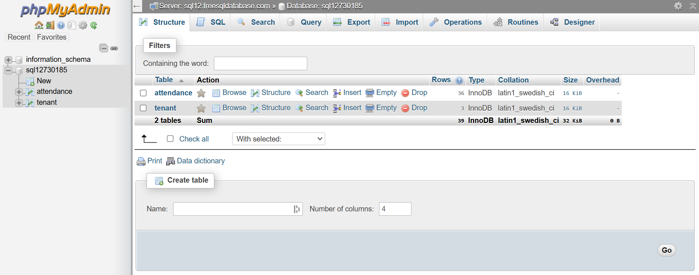

Figure 1: phpMyAdmin Page

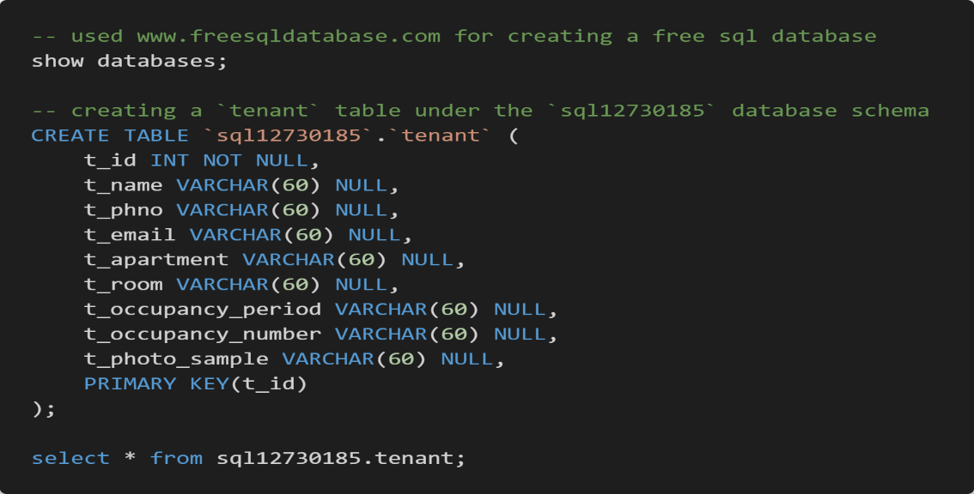

Figure 2: Tenant Table

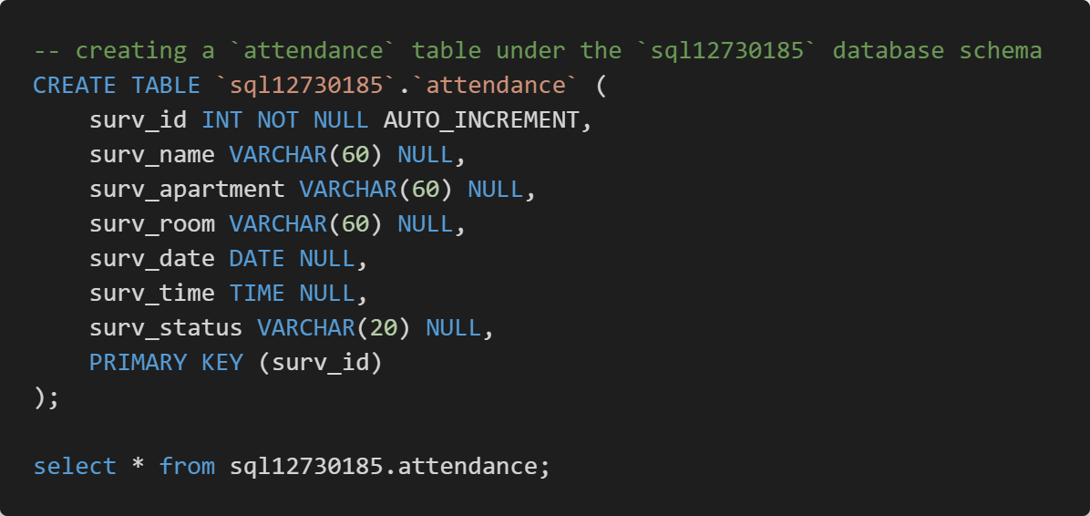

Figure 3: Attendance Table

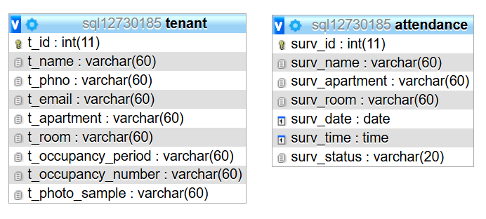

Figure 4: Table Design

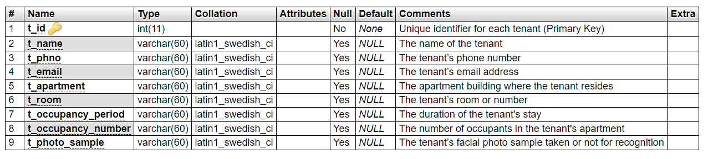

Figure 5: Tenant Table Structure

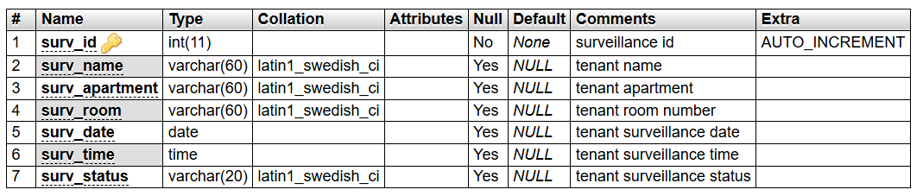

Figure 6: Attendance Table Structure

### Interaction Between Components

* **Tkinter + OpenCV**: Tkinter handles the user interaction and displays the interface, while OpenCV processes the visual data. For example, when the "Detect Face" button is pressed, OpenCV captures live video feedback for facial recognition, and Tkinter displays the results.
* **Tkinter + MySQL**: Tkinter interacts with the MySQL database using the **mysql.connector** library to insert or fetch *tenant* data and display it on the GUI. For instance, tenant details entered via the GUI are stored in the *tenant* table.
* **OpenCV + MySQL**: The photo samples(50) captured by OpenCV during tenant registration are stored locally. When recognition is performed, the system retrieves the “classifier_data.xml” data which is generated after training the photos from the tenant image samples and compares the data with the live video stream for identification.

## **Application Workflow**

### Application Architecture Diagram

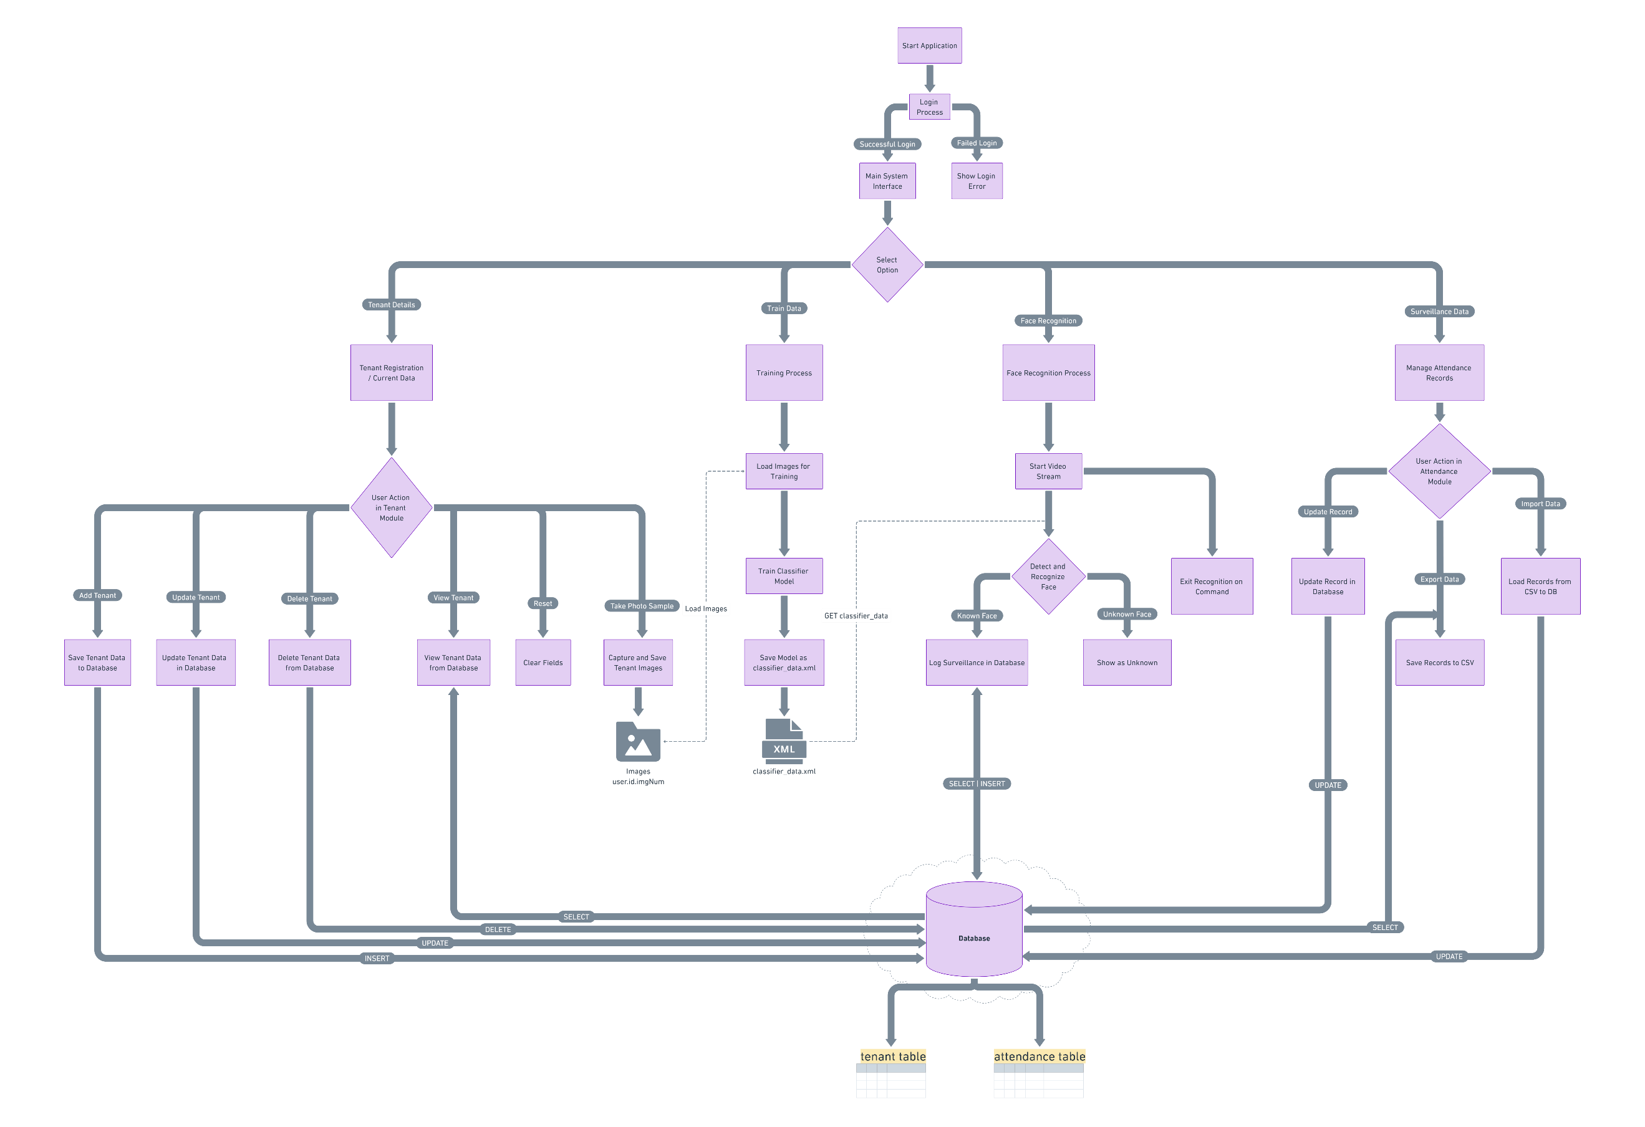

Figure 7: Application Architecture Diagram

### Algorithms Used

#### Haar Cascade Algorithm for Face Detection

The Haar Cascade algorithm is a powerful method used for object detection, particularly in face detection. It leverages machine learning techniques and was introduced by Paul Viola and Michael Jones.

##### Step 1: Haar Features

* The algorithm uses Haar-like features, which are rectangular features similar to convolution operations.
* These features calculate the difference in intensity between adjacent rectangular regions within an image. Common patterns include edges, lines, and four-rectangle features.

##### Step 2: Integral Image

* To accelerate feature computation, the image is transformed into an integral image. This structure allows the quick calculation of the sum of pixel intensities within a rectangular region.

##### Step 3: Adaboost Training

* The algorithm uses the Adaboost technique to select the most important features from thousands of possible Haar features.
* Adaboost creates a strong classifier by combining multiple weak classifiers, each trained on a small subset of features.

##### Step 4: Cascade of Classifiers

* The final detection process involves a series of classifiers arranged in a cascade.
* The image is scanned through each stage of the cascade, rejecting regions that do not contain the object (e.g., a face) and retaining regions that might contain the object.
* This approach minimizes computation time by quickly discarding non-face regions.

##### Advantages and Applications

* Haar Cascade is effective for real-time face detection and has been widely used in surveillance systems, mobile applications, and more.
* The algorithm's performance depends on the quality of the training data and is efficient in detecting frontal faces.

#### Local Binary Patterns Histogram (LBPH) Algorithm

The LBPH algorithm is a widely used method for facial recognition due to its simplicity and effectiveness.

##### Step 1: Grayscale Conversion

* The LBPH algorithm begins by converting the input facial image to grayscale, simplifying the data processing by removing color information.

##### Step 2: Local Binary Patterns (LBP) Calculation

* The image is divided into small regions, and each pixel in these regions is compared to its neighbors.
* If the neighboring pixel's intensity is greater than or equal to the central pixel, a binary value of 1 is assigned; otherwise, it is given 0.
* These binary values are concatenated to form an 8-bit number, representing the local pattern of the region.

##### Step 3: Histogram Construction

* A histogram is created for each region, representing the frequency of the different 8-bit patterns.
* These histograms are then combined to form a single, large histogram, capturing the texture features of the face.

##### Step 4: Facial Recognition

* The generated histograms of the input image are compared with those stored in a database using distance metrics (e.g., Euclidean distance) to find the best match.

##### Advantages and Applications

* The LBPH algorithm is robust to lighting variations and can recognize faces even with small changes in facial expressions.
* It's commonly used in real-time applications where speed and efficiency are crucial.

### Why Convert to Grayscale for Face Recognition and Detection?

#### Simplified Computation

Grayscale images are composed of a single intensity channel, while color images have three channels (Red, Green, and Blue). Processing a single channel significantly reduces the computational complexity and speeds up the algorithms, which is crucial for real-time applications like facial recognition.

#### Uniformity and Consistency

Grayscale images standardize the data input. Different color variations can introduce inconsistency, as the same face may appear different in various lighting conditions or due to changes in skin tone. By using a monochrome image, algorithms can focus on facial features rather than being affected by color differences.

#### Feature Extraction Efficiency

Both the LBPH and Haar Cascade algorithms rely heavily on extracting texture and pattern features from the image. These features, such as edges, lines, and textures, are more easily distinguishable in terms of intensity variations rather than color variations. The lack of color ensures that the algorithms detect these features more reliably.

#### Reducing Noise and Complexity

Color images often introduce noise and unnecessary details, which can hinder the feature detection process. Grayscale images simplify the data and help to minimize noise, making it easier for the algorithms to identify important features like edges, contours, and shapes.

#### Performance and Storage Considerations

Grayscale images use less memory compared to color images. In applications where speed and storage are critical, such as surveillance systems or mobile devices, using grayscale reduces the amount of data that needs to be processed and stored.

#### Lighting Variability

Using grayscale images makes the system less sensitive to changes in lighting and shadows, as color information can vary drastically under different lighting conditions. Grayscale images help maintain the robustness of the algorithm by focusing on intensity differences rather than color variations.

### Why Not Use Color Images?

* **Increased Complexity**: Processing color images would require analyzing three separate channels, increasing the complexity of the algorithms without necessarily improving performance. The additional data might not contribute significantly to recognizing facial features.
* **Redundancy in Color Information**: For most facial recognition and detection tasks, the color information does not add value. The essential features needed to distinguish a face, such as the shape of the eyes, nose, and mouth, are well represented by intensity variations in grayscale.
* **Ineffective for Edge Detection**: Color gradients are less effective in highlighting edges and important contours needed for these algorithms. Grayscale images, with their clear intensity transitions, are better suited for detecting edges and structural patterns.

### Algorithms That Use Color Images

#### Deep Learning Models (e.g., CNNs)

* Convolutional Neural Networks (CNNs) can be trained to use RGB channels, extracting features not only from the intensity but also from color information.
* Color-Based Skin Detection: Algorithms that use color features, such as HSV (Hue, Saturation, Value) or YCbCr (Luminance, Chrominance) color spaces, are also used to improve face detection by identifying skin-like regions.

#### Fusion Models

* These models combine features from both grayscale and color channels, using a multi-modal approach to improve performance.

### Advantages of Using Color Images

#### Improved Accuracy in Some Cases

* Color images provide additional information that can be useful in specific contexts. For example, detecting skin tones or identifying specific features that may stand out due to color differences, such as makeup or scars.
* This is particularly beneficial when distinguishing faces in environments where skin color differentiation is crucial.

#### Skin Color-Based Detection

* Using color images enables algorithms to use skin tone as a feature, which can help improve detection in some cases, especially in cluttered backgrounds or non-frontal faces.
* Algorithms can use color models like YCbCr (Luminance, Chrominance) or HSV (Hue, Saturation, Value) to isolate skin tones, reducing the search space for detecting faces.

#### Contextual Information

* Color can provide contextual information about the environment or even clothing, which may help in multi-person tracking or scenarios where additional cues are needed.

### Disadvantages of Using Color Images

#### Increased Computational Load

* Processing three color channels (RGB) rather than a single grayscale channel requires significantly more computation, leading to slower performance. This is particularly problematic for real-time applications like surveillance or access control systems.

#### Higher Memory Usage

* Color images take up more space, which increases memory usage and storage requirements. This can be a drawback in systems with limited resources, like embedded systems or mobile devices.

#### Susceptibility to Lighting Variations

* Color images are more affected by changes in lighting conditions, shadows, or reflections. The same object can appear very different in varying lighting environments, making the algorithms less robust compared to grayscale-based approaches.

#### Potential for Increased Noise

* Color images can introduce additional noise, especially under poor lighting conditions, making it harder for the algorithm to extract meaningful features for recognition.

### Comparison: Grayscale vs. Color-Based Algorithms

|  |  |  |
| --- | --- | --- |
| Aspect | Grayscale Algorithms (LBPH, Haar Cascade, etc.) | Color-Based Algorithms (CNNs, Skin Detection, etc.) |
| **Speed** | Faster due to processing a single channel. | Slower due to three channels and more complex calculations. |
| **Memory Usage** | Lower memory requirements. | Higher memory usage. |
| **Feature Extraction** | Focuses on intensity variations, edges, and patterns. | Can extract features using color information, useful in specific contexts. |
| **Lighting Robustness** | More robust to changes in lighting conditions. | Sensitive to lighting variations, shadows, and reflections. |
| **Noise Susceptibility** | Generally lower noise levels. | Higher susceptibility to noise, especially in poor lighting. |
| **Use Cases** | Real-time applications, embedded systems, surveillance. | Advanced recognition tasks, systems where color information is valuable. |
| **Complexity** | Simpler and easier to implement. | More complex, requiring more computational power and optimization. |

Table 1: Comparison: Grayscale vs. Color-Based Algorithms

### Pseudo-Code for Modules

#### Face Recognition System_Login.py

START  
 IMPORT necessary modules: Tkinter, customtkinter, PIL, os  
  
 DEFINE class LoginApp with the constructor method:  
 - SET window properties (geometry, resizable, icon)  
 - CALL method to load images  
 - CALL method to build the user interface  
  
 METHOD load_images:  
 - LOAD images for the side image, email icon, password icon, eye (show/hide) icons, and Google icon  
  
 METHOD build_ui:  
 - CREATE and place a side image using a label  
 - CREATE a frame for the login form and set properties  
 - ADD a welcome message and sign-in prompt  
 - ADD labels and entry fields for:  
 - Email, with an email icon  
 - Password, with a password icon  
 - ADD a button to toggle password visibility with an eye icon  
 - ADD a login button with an authentication command  
 - ADD a button for Google sign-in  
  
 METHOD authenticate:  
 - RETRIEVE email and password from entry fields  
 - CHECK if the username is "admin" and the password is "password"  
 - IF credentials are correct:  
 - SHOW success message  
 - CLOSE the current window  
 - RUN main.py script  
 - ELSE:  
 - SHOW error message for invalid credentials  
  
 METHOD toggle_password:  
 - CHECK the current state of the password field  
 - IF password is hidden:  
 - SHOW password  
 - CHANGE eye icon to "hide" version  
 - ELSE:  
 - HIDE password  
 - CHANGE eye icon to "show" version  
  
 MAIN block:  
 - CREATE a customtkinter application instance  
 - INITIALIZE LoginApp with the instance  
 - START the main event loop  
END

#### main.py

START  
 IMPORT necessary modules: tkinter, FaceRecognitionSystem, attendance, etc.  
  
 DEFINE class MainApp with the constructor method:  
 - SET window properties (geometry, resizable, icon)  
 - ADD a button to launch the face recognition system  
 - ADD a button to open attendance management   
  
 METHOD launch_face_recognition:  
 - OPEN a new window with FaceRecognitionSystem (Face Recognition System)  
 - CLOSE the current window if face recognition is launched  
  
 METHOD open_attendance_management:  
 - OPEN the attendance system window for managing records  
  
 MAIN block:  
 - CREATE a tkinter window instance  
 - INITIALIZE MainApp with the instance  
 - START the main event loop  
END

#### db_connection.py

START  
 IMPORT necessary modules: mysql.connector, Error from mysql.connector, dotenv, os  
  
 CALL load_dotenv() to load environment variables from the .env file  
  
 DEFINE FUNCTION get_db_connection:  
 TRY  
 - CREATE a connection object using mysql.connector.connect with parameters:  
 - host, username, password, database (from environment variables)  
 - CHECK if the connection is successful using conn.is_connected()  
 - IF connected:  
 - RETURN the connection object  
 EXCEPT Error as e:  
 - PRINT an error message with the exception details  
 - RETURN None  
  
 MAIN block (executed if the script is run directly):  
 - CALL get_db_connection and store the result in connection  
 - CHECK if the connection is successful:  
 - IF successful:  
 - PRINT "Connection successful!"  
 - CLOSE the connection  
 - ELSE:  
 - PRINT "Failed to connect to the database"  
END

#### tenant.py

START  
 DEFINE the tenant table schema in MySQL:  
 - Fields: t_id, t_name, t_phno, t_email, t_apartment, t_room, t_occupancy_period, t_occupancy_number, t_photo_sample  
 - Set primary key on t_id as unique  
  
 METHOD insert_tenant_data:  
 - CONNECT to MySQL database  
 - INSERT new tenant information into the tenant table  
  
 METHOD fetch_tenant_data:  
 - CONNECT to MySQL database  
 - FETCH tenant data from the database based on t_id or t_email  
 - RETURN tenant data  
  
 MAIN block:  
 - No main block as this script handles only database-related tasks  
END

#### train.py

START  
 IMPORT necessary modules: cv2, os, numpy, PIL  
  
 DEFINE function to load and preprocess training images:  
 - LOAD images from a specific directory (tenant images)  
 - CONVERT images to grayscale  
 - EXTRACT face regions using haarcascades  
  
 DEFINE function to train the LBPH face recognizer:  
 - TRAIN the LBPH recognizer using the prepared images and labels  
  
 DEFINE function to save the trained model:  
 - SAVE the trained model to a file for future use  
  
 MAIN block:  
 - CALL load and preprocess training images  
 - CALL train the LBPH recognizer  
 - CALL save the trained model  
END

#### face_recognition.py

START  
 IMPORT necessary modules: cv2, numpy, mysql.connector, time, PIL  
  
 DEFINE class FaceRecognitionSystem with the constructor method:  
 - SET up webcam capture  
 - LOAD the trained LBPH face recognizer model  
 - LOAD haarcascade for face detection  
  
 METHOD recognize_face:  
 - CAPTURE image from webcam  
 - DETECT faces using haarcascade  
 - MATCH detected faces with the trained LBPH model  
 - IF a match is found:  
 - RETRIEVE tenant details from the database (using tenant ID)  
 - DISPLAY tenant information (name, apartment, etc.)  
 - MARK attendance with a timestamp in the database  
 - ELSE:  
 - SHOW as "UNKNOWN" message  
  
 MAIN block:  
 - INITIALIZE FaceRecognitionSystem  
 - RUN the face recognition process continuously  
END

#### attendance.py

START  
 IMPORT necessary modules: tkinter, sqlite3, csv  
  
 DEFINE class AttendanceApp with the constructor method:  
 - SET window properties (geometry, title)  
 - ADD a button to fetch attendance data from the database  
 - ADD a button to export data to CSV  
 - ADD a button to import data from CSV  
 - ADD input fields to manually add or reset attendance records  
  
 METHOD fetch_attendance_data:  
 - CONNECT to MySQL database  
 - FETCH attendance records based on specific filters (date, tenant)  
 - DISPLAY the fetched data in a table (using ttk.Treeview)  
  
 METHOD save_to_csv:  
 - EXPORT current attendance records to a CSV file  
  
 METHOD import_from_csv:  
 - IMPORT attendance records from a CSV file and update the database  
  
 MAIN block:  
 - INITIALIZE AttendanceApp with Tkinter  
 - START the main event loop  
END

## **Development Process**

* Login Page module.
* Tenant registration module and database operations.
* Training data module.
* Facial recognition module (LBPH training and detection).
* Logging of tenant data to the database and real-time surveillance.

## **Testing and Quality Assurance**

### Unit Testing

* **Objective**: Ensure individual components (such as tenant registration, face detection, and training) function correctly.
* **Method**: Test each module (Tenant, Face_Recognition, Train) independently by simulating user actions like registering a tenant or detecting a face.

### Integration Testing

* **Objective**: Test the interaction between different components (Tkinter, OpenCV, MySQL).
* **Method**: By checking if the system can handle operations that require multiple components to work together (e.g., registering a tenant and saving their details in the database, capturing photos, and training the model)

### Functional Testing

* **Objective**: Ensure the system meets the functional requirements (e.g., tenant registration, visitor logging, face recognition).
* **Method**: Use test cases that mimic real-world user interactions:
  + Register a tenant with valid and invalid data.
  + Check if the face detection and recognition work as expected with clear and blurry images.
  + Ensure the system can log a visitor correctly.

### Performance Testing

* **Objective**: Evaluate the system’s performance under different loads.
* **Method**: Simulate various numbers of tenants and visitors to test how the application handles large datasets. This includes testing the time taken for face recognition and data retrieval from the database.

### User Acceptance Testing (UAT)

* **Objective**: Validate the system against the expectations of the end-users (e.g., gated community security personnel).
* **Method**: Allow actual users to test the system in a real environment and gather feedback on usability, performance, and reliability.

### Exception and Error Handling Testing

* **Objective**: Ensure the system handles errors gracefully without crashing.
* **Method**: Simulate scenarios such as missing tenant photos, database connection failures, or invalid data inputs.

### Security Testing

* **Objective**: Test for vulnerabilities, particularly in the login system and data handling.
* **Method**: Conduct tests to ensure secure storage of passwords, and restricted access to sensitive data.

## **Deployment Strategy**

### Microsoft Software Installer (.msi)

* Packaging Tool: ***cx_Freeze*** was used to create an executable ***.msi*** installer for easy deployment of the Visitor Management System.
* Installation Process:
  + The necessary packages were installed using:

pip install cx_Freeze --upgrade  
pip install --upgrade cx_Freeze mysql-connector-python

* The project was packaged using ***python setup.py bdist_msi***, generating an ***.msi*** file for distribution.

##### setup.py

**import** cx_Freeze  
**import** sys  
**import** os  
  
base = None  
  
# to get the Tcl library path  
#from tkinter import Tcl  
#print(Tcl().eval("info library"))  
#  
  
**if** sys.platform == 'win32':  
    base = "Win32GUI"  
  
# Ensure the paths to Tcl and Tk libraries are correctly set  
os.environ['TCL_LIBRARY'] = r"C:\Program Files\WindowsApps\PythonSoftwareFoundation.Python.3.11_3.11.2544.0_x64__qbz5n2kfra8p0\tcl\tcl8.6"  
os.environ['TK_LIBRARY'] = r"C:\Program Files\WindowsApps\PythonSoftwareFoundation.Python.3.11_3.11.2544.0_x64__qbz5n2kfra8p0\tcl\tk8.6"  
  
executables = [cx_Freeze.Executable("main_window.py", base=base, icon="appicon.ico")]  
  
cx_Freeze.setup(  
    name="Face Recognition System",  
    version="16.0",  # Update the version number as needed  
    description="Visitor Management System for Gated Communities Using Python and Computer Vision",  
    options={  
        "build_exe": {  
            "packages": ["tkinter", "os", "mysql.connector"],  # Include necessary packages  
            "includes": ["mysql.connector._version"],  # Add _version to includes  
            "include_files": [  
                "appicon.ico",  # Include application icon  
                'tcl86t.dll',  # Include the Tcl DLL  
                'tk86t.dll',  # Include the Tk DLL  
                'appImages',  # Include application images folder  
                'img_data',  # Include image data folder  
                'appDatabase',  # Include database folder  
                '.env', # Include database creds  
                'haarcascade_frontalface_default.xml'  
            ]  
        }  
    },  
    executables=executables  
)

##### What is the setup.py File?

*setup.py* is a Python script used for packaging and distributing Python applications. It provides all the necessary information for tools like *cx_Freeze* to generate executable files for the project. When we run commands like *python setup.py bdist_msi*, the script tells *cx_Freeze* how to package the Python script(s) into a standalone executable for distribution.

##### Why mention *Win32* and *Win32GUI*?

win32 and Win32GUI: These are base settings that tell cx_Freeze how to build the executable, specifically for the Windows platform.

* **win32**: This indicates that the build is targeting the Windows operating system. It is needed to ensure compatibility when packaging the application for Windows.
* **Win32GUI**: This base setting is used when creating a GUI (Graphical User Interface) application. By specifying Win32GUI, the executable will be built without a console window appearing when we run the application. This is important for GUI applications like “Visitor Management System”, which uses tkinter for the graphical interface.

##### Why Use *.dll* Files?

* **.dll (Dynamic Link Library):** These are libraries that contain code and data that multiple programs can use simultaneously. For this application, *tcl86t.dll* and *tk86t.dll* are required for tkinter to function correctly in a standalone executable.
* **Reason for Including .dll Files:** When we use *cx_Freeze* to package the Python application, it needs to bundle all dependencies, including *tcl* and *tk* libraries, so that the application can run independently of a full Python installation. The *.dll* files ensure that the tkinter GUI framework works as expected.

##### What Are *tcl* and *tk* Libraries?

* *tcl* and *tk* are libraries used by *tkinter*, Python's standard GUI toolkit.
  + ***tcl* (Tool Command Language):** A scripting language used for various purposes, including embedded applications and web development.
  + ***tk* (Toolkit):** A GUI toolkit for tcl that provides elements like buttons, labels, and windows, which tkinter uses to create graphical user interfaces.
* **Why Are They Used?:** When we use *tkinter* in the Python application*, tcl* and *tk* are essential components. They provide the functionality to create and manage the GUI elements. Including these libraries ensures that the tkinter GUI works properly in the standalone application, even if the target system does not have Python or tkinter installed.

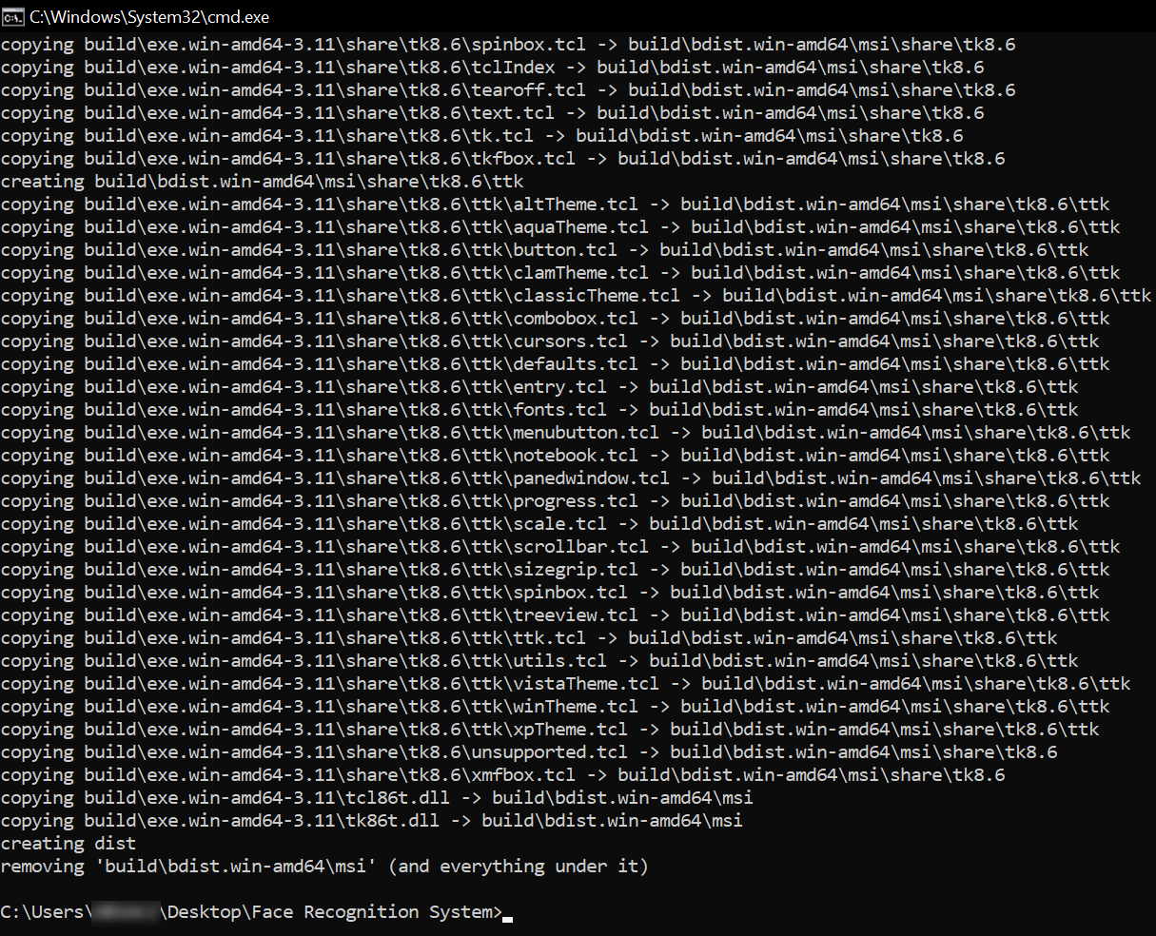

Figure 8: msi build

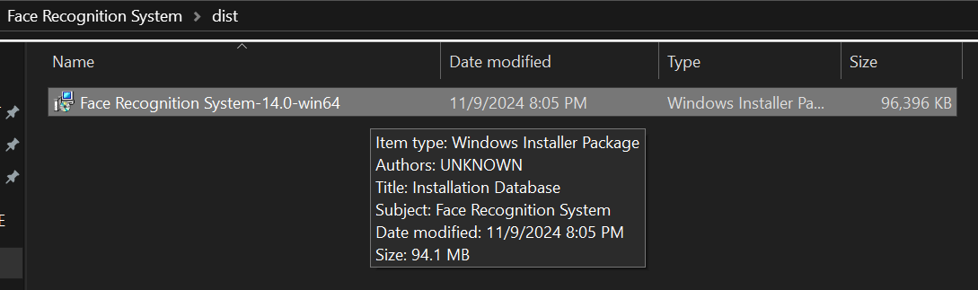

Figure 9: msi file

* Distribution: The ***.msi*** installer simplifies the installation process for end users, ensuring that all dependencies are bundled and the system is ready to be deployed on target machines.

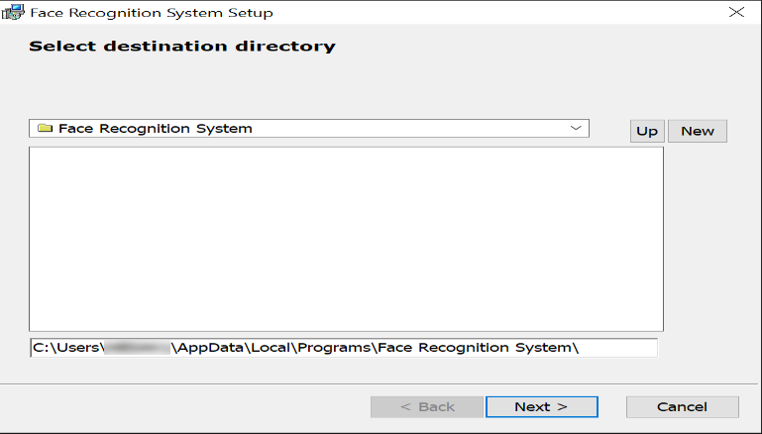

Figure 10: Application Installation

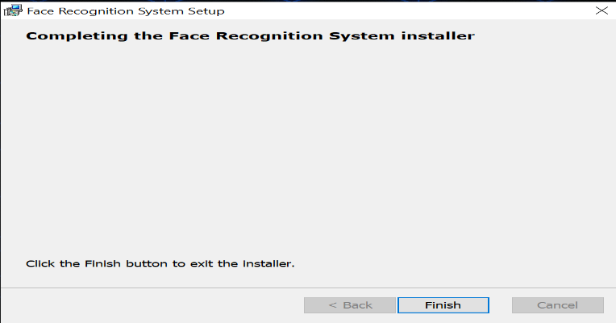

Figure 11: Application Installation Completion

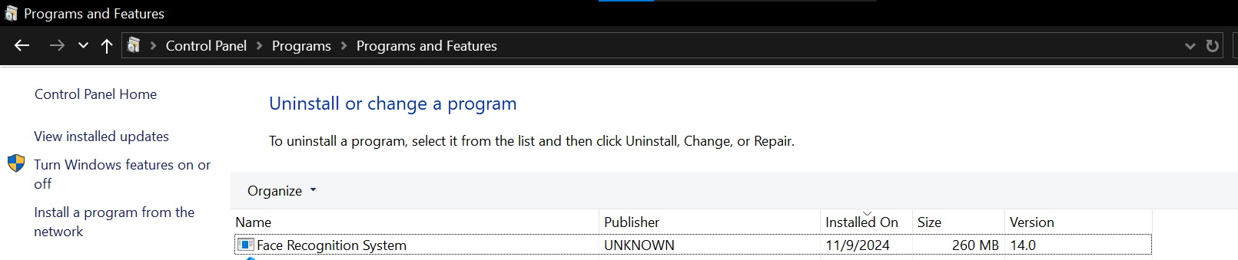

Figure 12: Control Panel

### Local Deployment Setup

* Objective: Deploy the system on a local machine for individual or small-scale testing.
* Steps:
  + Install all required dependencies (OpenCV, Tkinter, MySQL connector, etc.).
  + Set up the MySQL database locally or use freesqldatabase.com.
  + Run the application locally using Python’s built-in runtime.

# **Final-Semester Update Details**

I have successfully completed my project as per the 16-week plan. Attached are the screenshots of the work completed. The theoretical section, covering the entire project, is provided above. Please find the final deliverables as per the complete 16-week timeline.

## Login Window

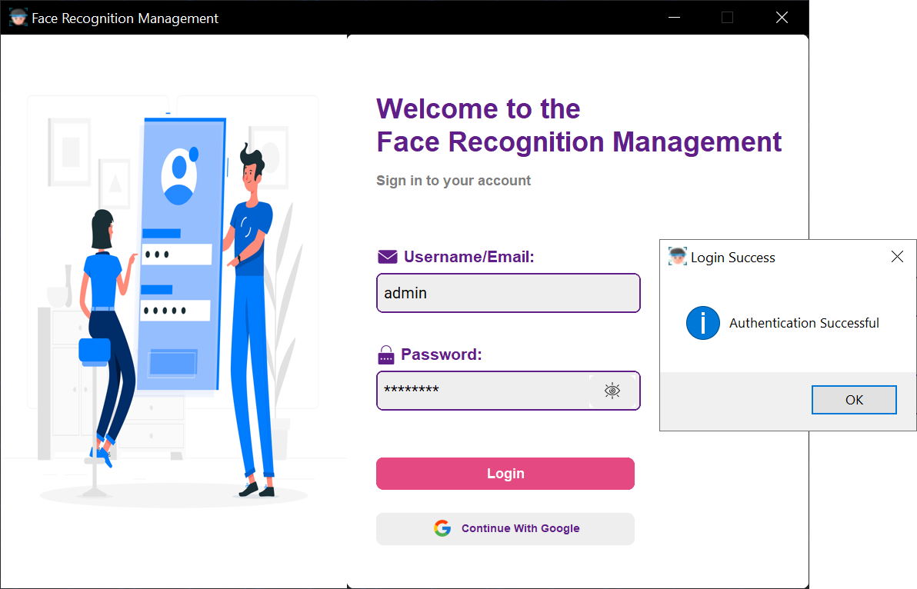

Figure 13: Application login

## Main Interface:

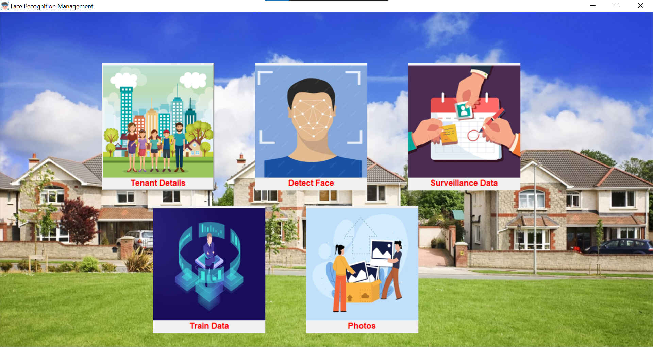

Figure 14: Application main page

## Tenant Registration and Database

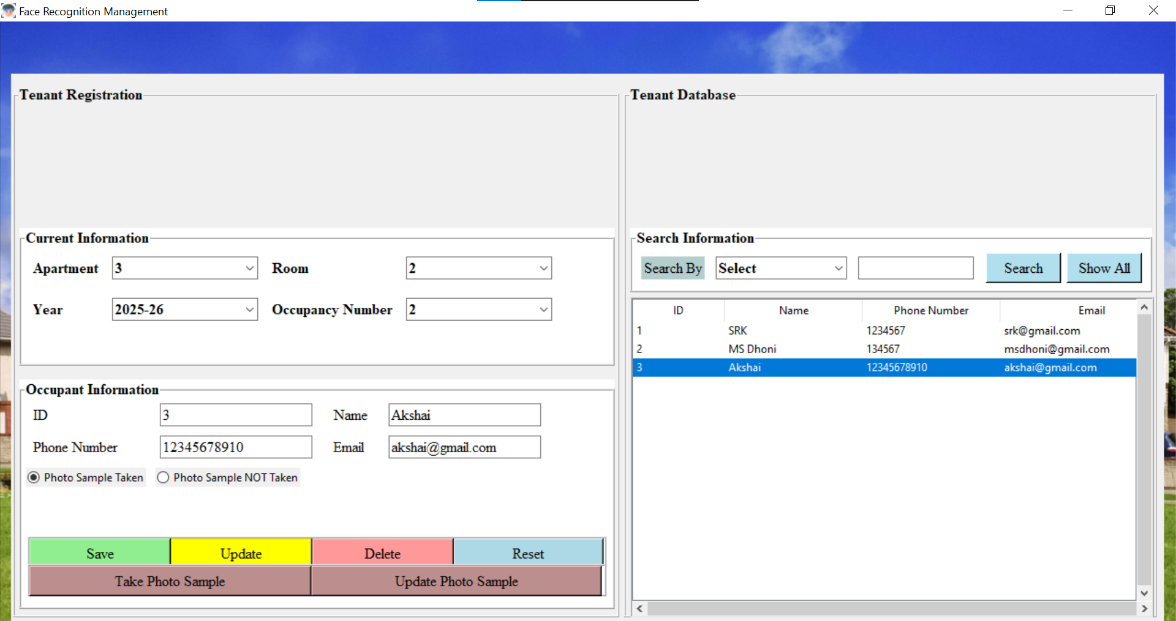

Figure 15: Tenant registration and database

## Take Photo Samples

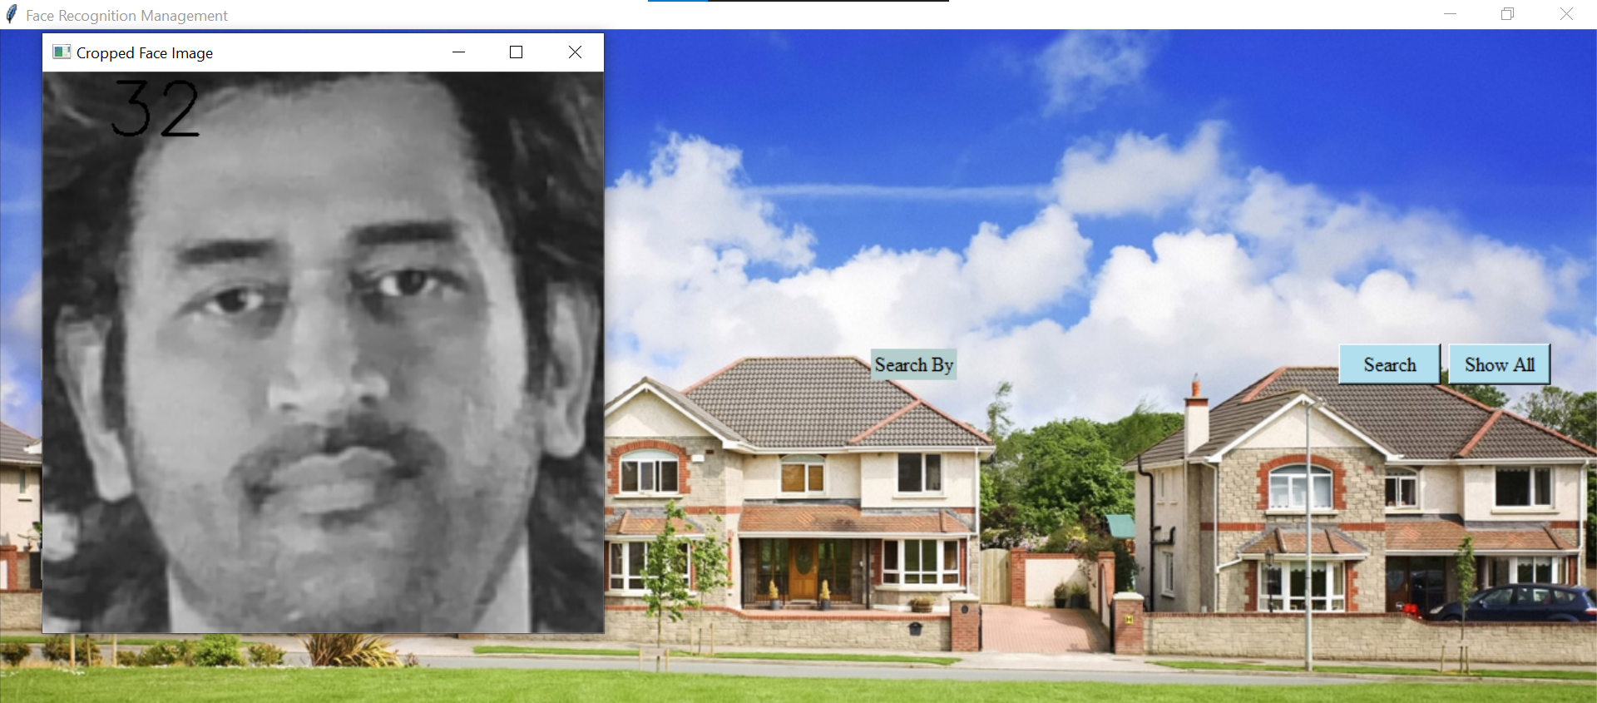

Figure 16: Taking photo samples

## Face Detect with Camera Window

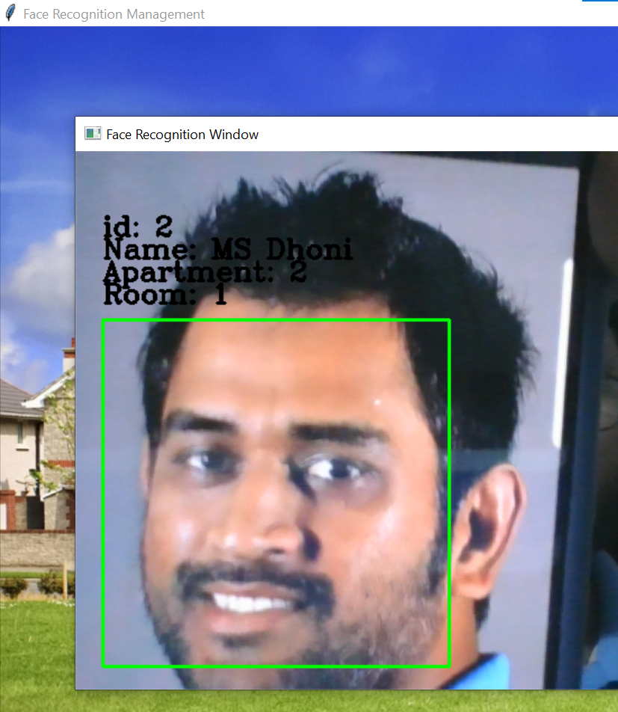

Figure 17: Face detection with camera window: Known face

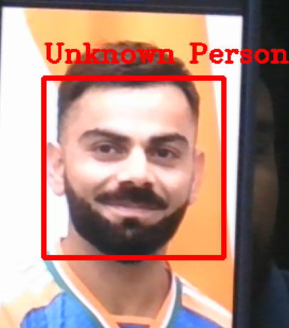

Figure 18: Face detection with camera window: Unknown face

## Train Data Window with Loading Images

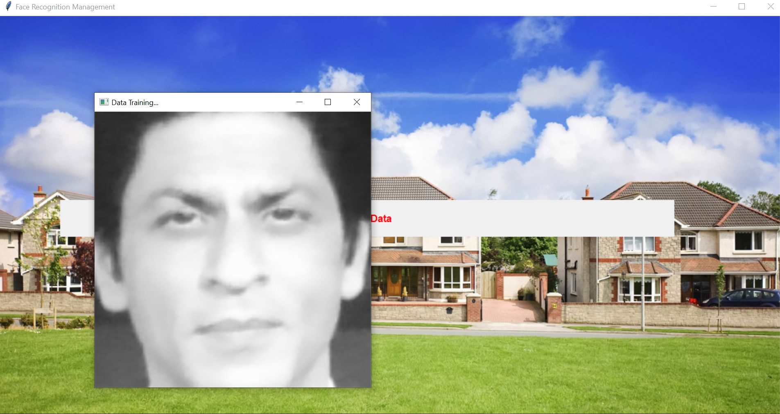

Figure 19: Training image dataset

## Photos for Training

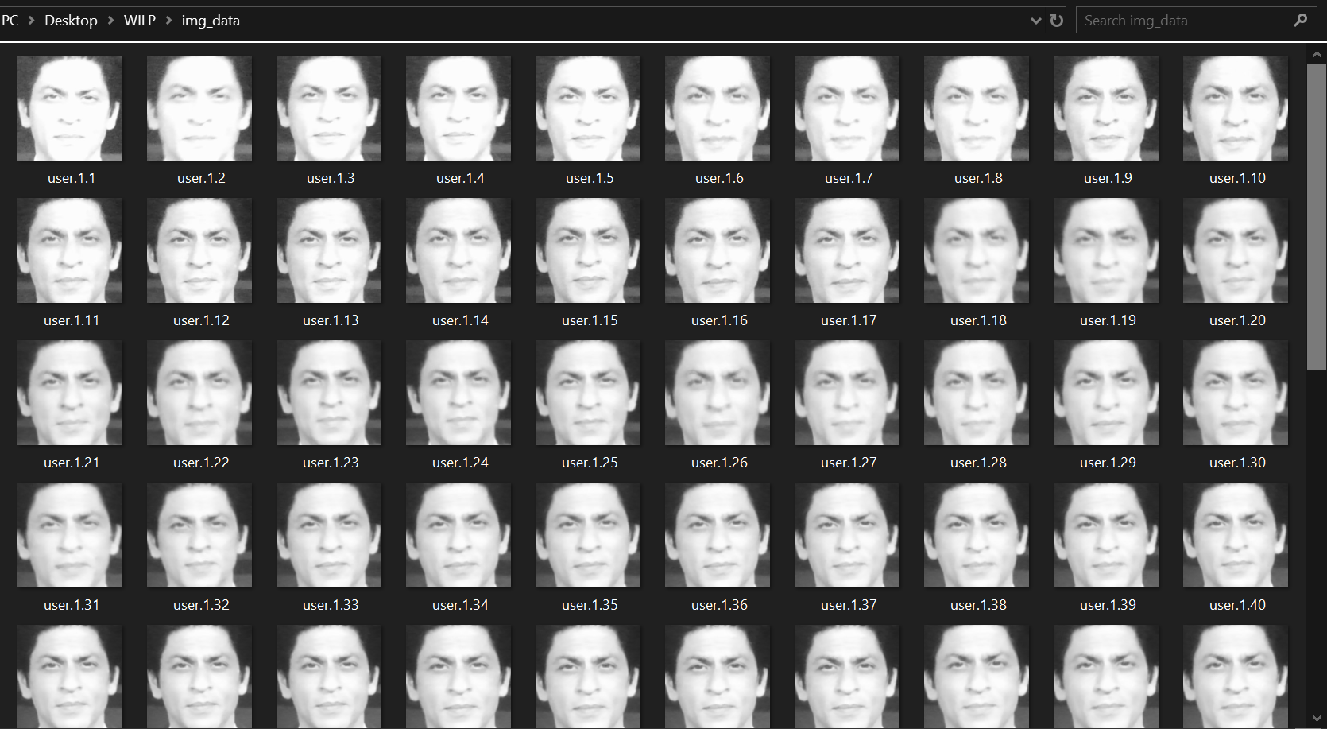

Figure 20: Tenant image dataset

## Automated Surveillance Database

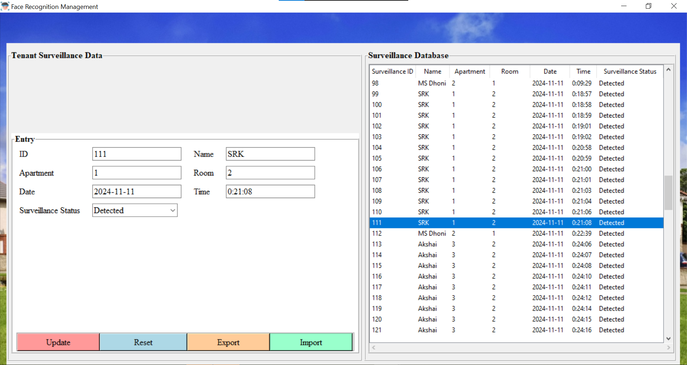

Figure 21: Automated Surveillance Database

# **Challenges Faced During Project Development**

* **Weekly Free Database Renewal:**
  + The free database service provided by freesqldatabase.com requires regular renewal every 7 days. This limited service caused disruptions and added complexity to database management, necessitating manual intervention to ensure data availability and consistency.
* **Small Image Dataset:**
  + During the tenant registration process, only 50 image samples are collected for each individual. This relatively small dataset poses challenges in achieving high accuracy for the face recognition system. Consequently, subtle facial changes, such as expressions, hairstyles, or aging, can affect the performance and reliability of facial recognition.
* **Tkinter Compatibility Issues:**
  + Converting the project into an installable *.msi* file using *cx_Freeze* introduced unforeseen compatibility issues. The project uses both standard Tkinter and customtkinter components, and while they worked well in the Python environment, several inconsistencies arose during packaging. These included mismatched window sizes, font scaling problems, and varying DPI settings, making it challenging to ensure a uniform user experience.
* **Secure Data Saving:**
  + Currently, the system saves photo samples taken during the registration process and the trained model’s *.xml* file locally on the machine. This poses a security risk, as sensitive data, such as facial images, are vulnerable to unauthorized access or potential breaches. Implementing a more secure data storage mechanism remains a challenge.
* **System and Camera Limitations:**
  + The application's performance heavily depends on the underlying system and camera quality. Running the face recognition model efficiently requires a high-performance system to minimize lag, processing delays, and application failures. Similarly, a good quality camera is essential to capture clear images, which are crucial for accurate face recognition and detection.
* **Lighting Conditions and Environmental Factors:**
  + Variations in lighting conditions significantly impact the performance of the face detection and recognition algorithms. Poor lighting or shadows can make it difficult for the system to accurately detect and recognize faces, necessitating careful consideration of the installation environment.
* **Handling Multiple Face Recognition:**
  + Detecting and recognizing multiple faces simultaneously posed challenges, especially when dealing with crowded scenes or overlapping faces. Optimizing the model to handle these scenarios efficiently required additional testing and fine-tuning.

# **Future Plan of Work**

* **User Registration and Authentication Enhancements:**
  + Integrate the login page with Firebase or other services to allow new user registration and improve security.
  + Implement a secure, automatic password generation and reset service.
* **Advanced Authentication Methods:**
  + Enable Google Sign-In for a streamlined and secure login experience.
  + Ensure data security by implementing best practices for secure photo storage.
* **Spoofing Detection:**
  + Integrate algorithms to detect face spoofing using techniques like texture analysis or liveness detection.
* **License Plate Recognition:**
  + Develop and implement license plate recognition using computer vision algorithms like License plate recognition systems (LPRs) or You Only Look Once(YOLO), enhancing the system’s functionality for gated community surveillance.
* **Future-proofing and Scalability:**
  + Plan for integration with cloud storage services to handle increased data volume.
  + Implement load balancing strategies if expanding for larger deployments.
* **Enhanced Reporting and Analytics:**
  + Create detailed analytics dashboards for tracking visitor patterns and activity.
  + Develop a real-time alerting system for unauthorized access detection.
* **System Monitoring and Updates:**
  + Automate the deployment of updates and perform regular security audits.
  + Incorporate performance monitoring tools to maintain system efficiency.
* **Chatbot Integration:**
  + Add a chatbot to assist users with navigating the system, answering queries, and guiding visitors or tenants through registration and other processes.

# **Conclusion**

The **Visitor Management System for Gated Communities** successfully integrates advanced facial recognition technology to automate visitor registration and enhance security. By using Python, OpenCV, and a MySQL database, the system efficiently addresses the limitations of traditional visitor management methods, offering real-time logging and a user-friendly interface.

The project demonstrates the effectiveness of LBPH and Haar Cascade algorithms for reliable face detection and recognition. Despite challenges like limited image datasets and database renewal constraints, the system achieves its primary goals. Future enhancements will focus on improving security, scalability, and integrating additional features, such as spoofing detection and license plate recognition. This project lays a strong foundation for further advancements in smart community management systems.

# **Literature Reference**

1. Face Detection using Haar Cascades

<https://docs.opencv.org/4.x/d2/d99/tutorial_js_face_detection.html>

1. Face Recognition: Understanding LBPH Algorithm

<https://towardsdatascience.com/face-recognition-how-lbph-works-90ec258c3d6b>

1. Haar Cascades, Explained

<https://medium.com/analytics-vidhya/haar-cascades-explained-38210e57970d>